Surgical Correction of Coxa Vara by Valgus Osteotomy Using Plate versus Monolateral External Fixator
Mohamed Rabie Abdalla Saleh ¹ , Mohamed Abo Zeid ²
¹Faculty of Medicine, Department of Orthopedics, Helwan University.
²Faculty of Medicine, Department of Orthopedics, Banha University.
Corresponding author: Mohamed Rabie Abdalla Saleh
Email: docmohamedrabie@gmail.com
:mohamed.rabie@med.helwan.edu.com
Phone: 01006654001
Co-author: Mahmoud Abou Zied
Email: abouziedmz83@gmail.com
Phone: 01001196707

Abstract
Background: Efficient surgical repair of coxa vara can be challenging, including thorough clinical and radiological evaluation, preoperative strategy, implant choice, and attentive surgical intervention.
Objectives: To compare the outcome of surgical correction of developmental coxa vara with traditional plate versus monolateral external fixator.
Methods: This study included 20 children with developmental coxa vara ,the mean age at initial surgery was 10.1 +20 122 215 4371 (range 7 to 11 years).. The studied children were randomized and divided according to surgical management into; group (A) with monolateral external fixator and group (B) with traditional plate.
Hilgenreiner-epiphyseal angle (HEA) and the femoral neck-shaft angle (FNSA) were measured before surgery and at latest follow-up.
Results: After treatment, the mean FNSA in fixator group was significantly increased to 129.10± 3.35 degrees and in plate group significantly increased to 125.40± 3.17 degrees. Postoperatively, we recorded a mean ATD of 11.70± 3.20 mm, with significant changes (p=0.005) in fixator group and plate group showed a mean ATD of 8.70± 2.15 mm, with significant changes (p=0.005). Postoperative FNSA and ATD improved significantly in fixator group than plate group (p=0.021 & 0.024, respectively). There was a significant decrease in HE angles postoperative compared to preoperative in both groups (p=0.005). Also, postoperative HE angles improved significantly in fixator group than plate group (p=0.044).
Conclusion: Surgical correction of coxa vara by monolateral external fixator have a higher significant outcome than plate with easily reproducible, efficient in deformity correction and no evidence of deformity recurrence.
Keywords: Coxa Vara, Valgus Osteotomy, Monolateral External Fixator

Introduction
Congenital coxa vara is a developmental malformation characterised by a primary cartilaginous deficiency of femoral neck with an atypical reduction in the femoral neck-shaft angle (FNSA), greater trochanter overgrowth, femoral neck and lower limb shortening. Generally, the deformity is either absent at birth or didn't notified. This deformity is caused by a variety of disorders that can be classed as congenital, developmental, dysplastic, or traumatic. ¹
The nature of coxa vara can be severe, as the child develops growing limb length disparity, limp, discomfort, abductor weakness, and limited mobility. Developmental coxa vara is idiopathic disorder caused by a main deficiency in the endochondral ossification of the medial portion of the femoral neck.. ²
Many surgical techniques have emerged to treat developmental coxa vara.³ Despite well-executed osteotomies, recurrence rates range from 30% to 70%.⁴ This high rate explained by disease biomechanics. As the physis acquires a more vertical posture, Coxa vara lends itself to advancement. As a result, the forces acting through the hip became shearing rather than compressive. ⁵
Efficient surgical repair of coxa vara can be challenging, including thorough clinical and radiological evaluation, preoperative strategy, implant choice, and attentive surgical intervention. Normalizing the biomechanical forces will be aided by restoring the femoral capital physis to an approximately horizontal posture. The objective of surgical correction is to reduce Hilgenreiner's epiphyseal angle (HEA) to less than 38°. This has been found to lower the chance of recurrent coxa vara, independent of deformity cause or age of the patient. ⁶
It is reported that valgus osteotomy at the trochanteric or subtrochanteric level is the most reliable way for performing the surgical repair, which includes adjustments of the neck shaft angle and horizontal reorientation of the growth plate. Nonetheless, there is no agreement in the literature on the mechanics of osteotomy and fixation procedure. ^{7,8} Our rational is compare the outcome of surgical correction of developmental coxa vara with traditional plate versus monolateral external fixation.

Patient and methods
A prospective randomized control study included 20 children with developmental coxa vara , the mean age at initial surgery was 10.1 years (range 7 to 11 years). The study period from February 2019 to January 2021 ,all cases operated upon in Helwan University and 6 October health insurance Hospitals . Informed consent was obtained from all participants prior to enrollment in the study. The studied population was randomly selected by simple randomization and divided according to surgical management into; group (A) with monolateral external fixation and group (B) with traditional plate.
patients having coxa vara due to another cause, such as acquired, dysplastic, or congenital (e.g., fracture neck femur, fibrous dysplasia, or proximal femoral focal deficit), was excluded. The primary complaint of the patients in this research was a limp, with little or no pain. All patients had a short leg gait with an abductor lurch, a positive Trendelenburg test, restriction of abduction and internal rotation of the affected hip, and a positive Trendelenburg test. Before and one, three, six, and twelve months postsurgical, routine x - rays were taken, including an anteroposterior (AP) view of the pelvis and a frog lateral view of the afflicted hip. limb scanograms before surgery were obtained in all patients. HEA and NSA were measured preoperative and at last follow-up on the AP pelvis radiograph. All patients had a HEA > 60 and FNSA< 95.
Surgical technique:
All procedures were done under general anaesthesia. X ray both hip prior to the surgery is done in a supine position (Figure 1,4 ).
The affected lower extremity was draped. A real AP view of the affected hip was replicated on the C-arm monitor while the involved limb was kept in hip neutral posture. We used 2 proximal scahanz, putting the initial scahanz in the proximal segment when the leg is in the hip neutral position, excessive skin release around the half-pins is avoided following the corrective osteotomy. With direction from superolateral to inferomedial. Followed by second scahanz using the clamp to maintain proper direction of the second scahanz. Then placing distal two scahanz in the shaft leave the subtrochanteric area ready for osteotomy. A 2-cm transverse incision was created in the subtrochanteric region at the level of the intended osteotomy location. Multiple drill holes were created, which were subsequently joined together with an osteotome. Once the osteotomy was completed, the correction was accomplished by bringing the two clamps together connected with the rod to reach the corrected neck shaft angle needed under C arm control.( figure 2,3 ).
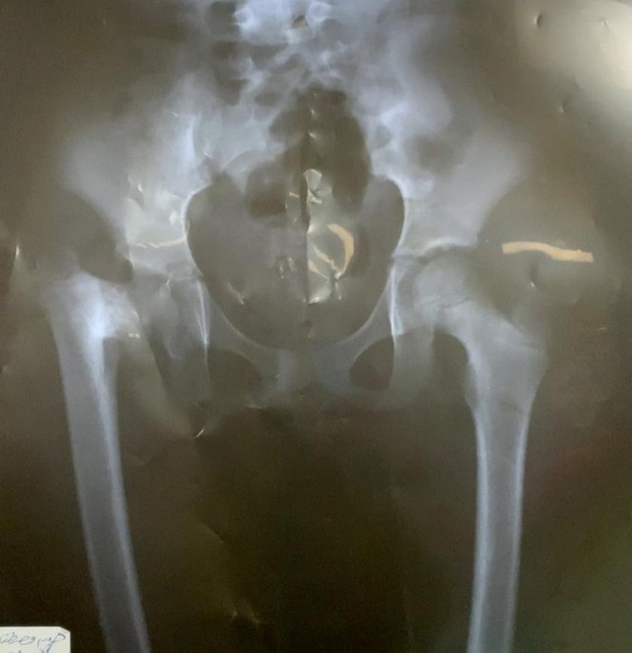
Figure 1: Coxa vara of right hip
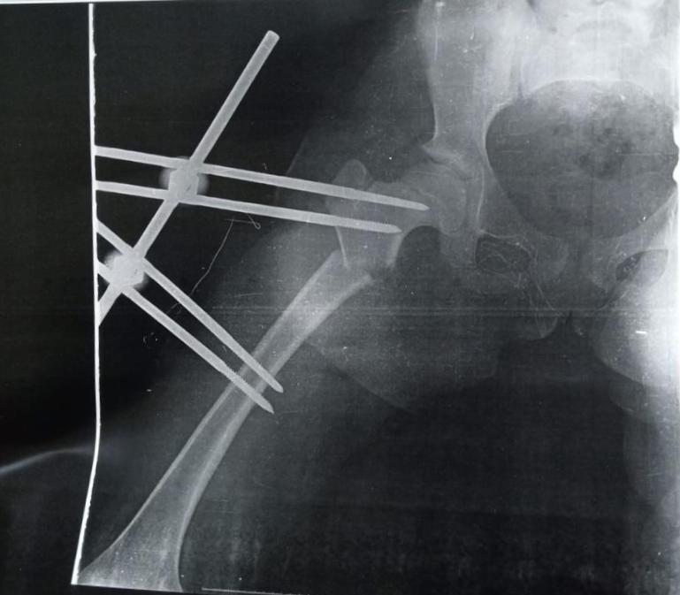
Figure 2: Fixation by external fixator

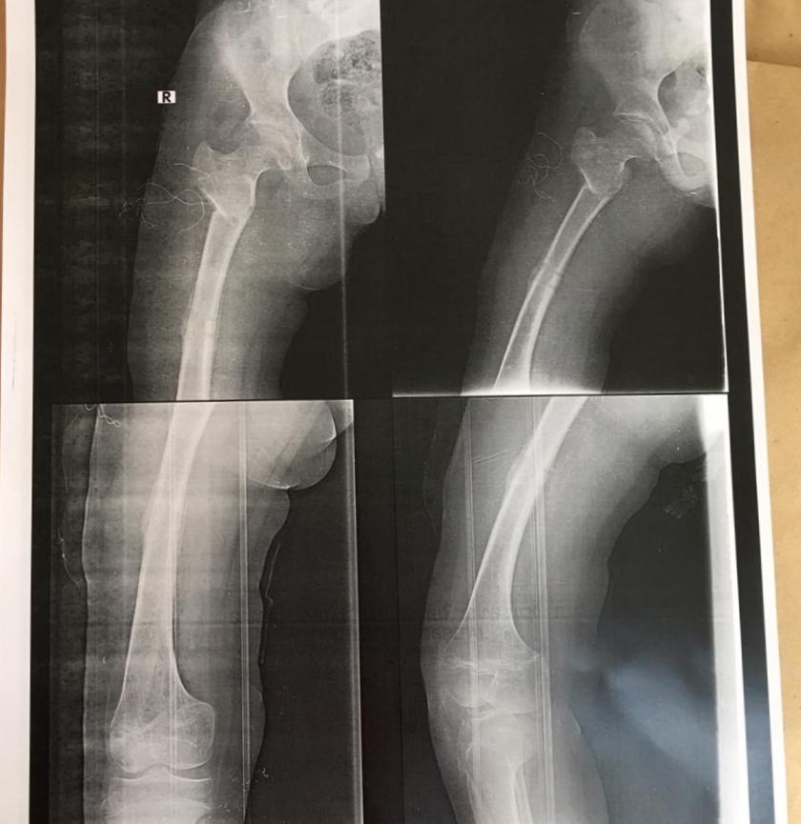
Figure 3: After removal of external fixator

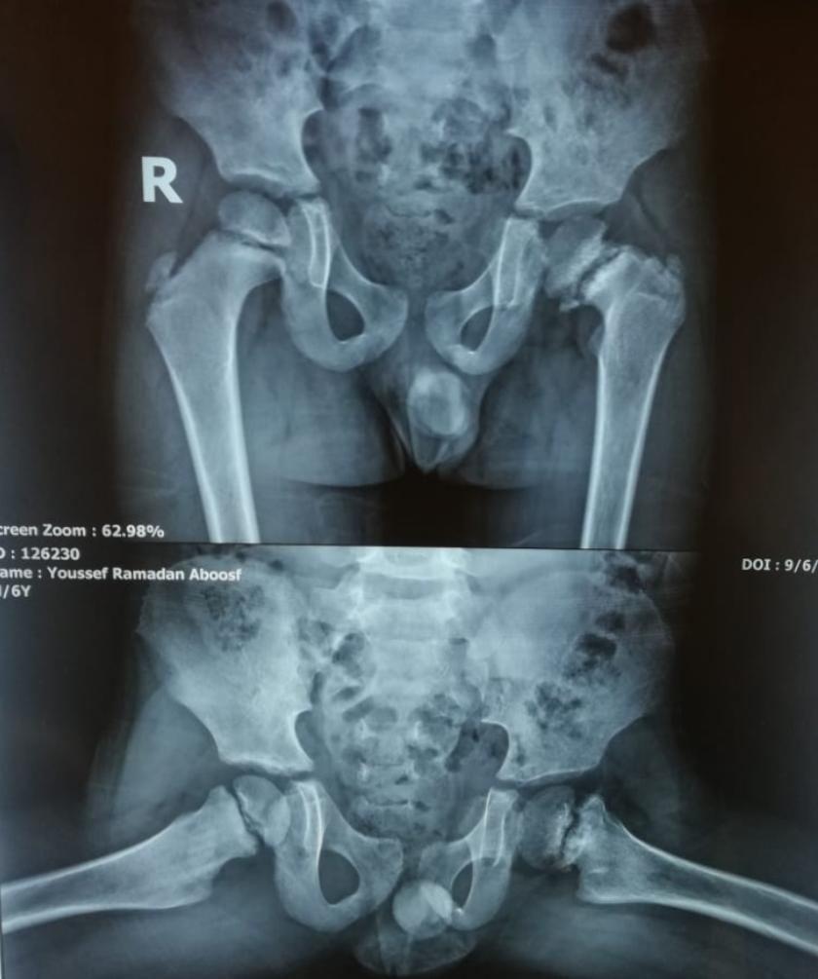
Figure 4: Coxa vara of the left hip

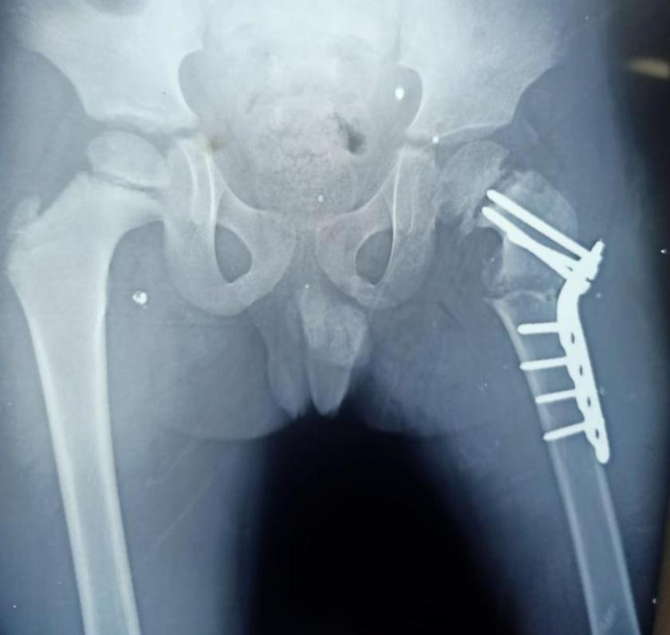
Figure 5: Fixation by smal DCP

Statistical analysis:
All data analyzed by SPSS (statistical package for social science) version 25 (IBM, Armonk, NY, USA) on IBM compatible computer. According to the type of data qualitative represent as number and percentage, quantitative continues group represent by mean ± SD. The following tests were used Paired t-test, Mann-Whitney's Test and chi-square test. P-value was considered significant if < 0.05.

Results
A total number of 20 children with pediatric coxa vara was enrolled. The age of studied cases ranged from 7 to 11 years with a mean was 8.40± 1.27 years. thirteen (65%) were males and seven (35%) were females. There was no significance among groups regarding age and gender. Both the groups were comparable in terms of age and gender. The male to female ratio in group A was 1.5:1 and in group B it was 2.33:1 (p-value=1.00). The mean age in group A was 8.50± 1.08 years with range being 7 to 10 years and in group B, mean age was 8.30± 1.49 years with range being 7 to 11 years (Table 1).
Preoperatively, the mean femoral neck shaft angle in group A was 88.50± 6.69 degrees with range from 80.0 to 95.0 degrees was found. After treatment with fixator the mean value was significantly increased to 129.10± 3.35 degrees with range from 120.0 to 133.0 degree (p=0.005). In group B Preoperatively, the mean FNSA was 88.0± 6.32degrees with range from 80.0 to 95.0 degrees was found. After treatment with plate the mean value was significantly increased to 125.40± 3.17degrees with range from 120.0 to 130.0 degree. Also, mean preoperative articulo-trochanteric distance (ATD) in group A was -7.40± 4.55 mm. Postoperatively, we recorded a mean ATD of 11.70± 3.20 mm, with significant changes (increase in distance postoperative (p=0.005). in group B, the mean Preoperative ATD was -7.40± 4.55 mm. Postoperatively, we recorded a mean ATD of 8.70± 2.15 mm, with significant changes (increase in distance postoperative (p=0.005). Postoperative FNSA and ATD improved significantly in fixator group than plate group (p=0.021 & 0.024, respectively) (Table 2).
Regarding complications, there were two cases in group A had Pin tract infection and one case in group B had Plate break and revision with no significant differences between the both groups (p= 0.217). There was significant decrease in HE angle postoperative compared to preoperative in both groups (p=0.005). Also, postoperative HE angle improved significantly in fixator group than plate group (p=0.044). Operative time was found to be significantly higher in group B compared to group A (p<0.001). Also, rate of blood loos was found to be significantly higher in group B compared to group A (p<0.001) as shown in table (3).
Table 1. Demographic characteristics of the study group
 |  | group A  with fixator (n=10) |  | group B  with plate  (n=10) |  | p- value
 |  | n | % | n | %
Age (years) | mean± SD  median  Range | 8.50± 1.08  8.50  7.0- 10.0 |  | 8.30± 1.49  8.0  7.0- 11.0 |  | 0.579╪
Gender | Male | 6 | 60.0% | 7 | 70.0% | 1.00 ‡
 | Female | 4 | 40.0% | 3 | 30.0%
╪ Mann- Whitney U test, ‡ Fischer Exact Test

Table 2. Preoperative and postoperative FNSA and ATD in the two studied groups
 |  | group A  with fixator  (n=10) | group B  with plate  (n=10) |  | p- value ╪
Femoral neck shaft angle (Pre.) | mean± SD  median  Range | 88.50± 6.69  90.0  80.0- 95.0 |  | 88.0± 6.32  90.0  80.0- 95.0 | 0.853
Femoral neck shaft angle (Post.) | mean± SD  median  Range | 129.10± 3.35  127.0  120.0- 133.0 |  | 125.40± 3.17  125.0  120.0- 130.0 | 0.021*
P-value (Pre/Post) |  | 0.005** |  | 0.005**
articulo-trochanteric distance (Pre.) | mean± SD  median  Range | -7.40± 4.55  -10.0  -12.0- 0.0 |  | -7.40± 4.55  -10.0  -12.0- 0.0 | 1.00
articulo-trochanteric distance (Post) | mean± SD  median  Range | 11.70± 3.20  9.50  5.0- 15.0 |  | 8.70± 2.15  7.50  5.0- 11.0 | 0.024*
P-value (Pre/Post) |  | 0.005** |  | 0.005**
^{╪ Mann- Whitney U test,}
Table 3. Postoperative outcome in the two studied groups
 |  | group A  with fixator  (n=10) |  | group B  with plate  (n=10) |  |  | p- value
 |  | n | % | n |  | %
Complications | No | 8 | 80.0% | 9 |  | 90.0% | 0.217 ‡
 | Pin tract infection | 2 | 20.0% | 0 |  | 0.0%
 | Plate break and revision | 0 | 0.0% | 1 |  | 10.0%
HE angle (Pre.) | mean± SD  median  Range | 64.30± 5.31  62.5  60.0- 75.0 |  |  | 63.5± 5.13  65.0  60.0- 70.0 |  | 0.912╪
HE angle (Post.) | mean± SD  median  Range | 29.70± 3.16  32.0  28.0- 40.0 |  |  | 32.90± 3.45  32.0  30.0- 40.0 |  | 0.044*╪
P-value (Pre/Post) |  | 0.005** |  |  | 0.005**
Operative time (min.) | mean± SD  median  Range | 22.0± 3.50  20.0  20.0- 30.0 |  |  | 41.0± 5.68  40.0  30.0- 50.0 |  | <0.001╪**
Blood loss (ml) | mean± SD  median  Range | 37.0± 8.23  35.0  30.0- 50.0 |  |  | 127.0± 9.49  120.0  120.0- 140.0 |  | <0.001╪**
╪ Mann- Whitney U test, ‡ Chi-square test

Discussion
There are few options for implants that provide stable fixation of the underlying proximal femoral osteotomy, and the variety is much more limited in young children. Moreover, any fixation tool must avoid the proximal femoral growth plate, giving just a little proportion of bone accessible for stable attachment. ⁹ Even in patients with well-performed osteotomies, it is reported a recurrence rates ranging from 30% to 70%. ¹⁰ When the HEA was corrected to less than 38°, 95% had no return of varus deformity. Some analysts have suggested that the HEA be overcorrected to the usual (anatomic) value of 22° to prevent recurrences. 11 In contrast, the head-shaft angle was not shown to be a good predictor of suitable adjustment.¹¹ The recurrence was mainly due to the loss of correction angle resulting from a weak fixation.¹²
Fixation tools for hip osteotomy include an angle blade plate, dynamic sliding hip screws, tension band wire, and an external fixator. ¹³⁻¹⁶ There is information available on the kind of implant chosen to promote stability at the osteotomy site. Khan et al. ¹⁷ published the outcomes of a proximal femoral valgus osteotomy with a sliding hip screw in treating coxa vara following a nonunion femoral neck fracture. Fassier et al.¹⁸ employed a combination of Kirschnerwires and a rod to offer fixation strength following coxa vara correction in children with osteopenic bone. This achievement might be achieved by inserting a technically challenging but difficult-to-apply intramedullary nail into a bowed proximal femur.
Some studies reported that the most significant predictor of recurrence is the postoperative HE angle. Desai and Johnson observed that in 12 hips, HE angle of 35 degrees after surger provided a good outcomes with no recurrence. ¹⁹ Cordes et al. reported 14 cases in which the HE angle was adjusted to 40 degrees or less, and a great outcome might be predicted. ²⁰ Carroll et al.¹² found that when the HE angle was reduced to less than 38 degrees, 95 % had no recurrence of coxa vara. Recurrence was unrelated to age of the patient, kind of surgery, type of implant, or aetiology.
In the present study, the authors want to compare between traditional pale versus minimally invasive percutaneous approach for the correction of coxa vara using monolateral external fixation. Several studies concluded that the HE angle should be less than 38°- 40°, otherwise there was a risk of recurrence. The current study was not significantly different from previous studies in that no hips needed to be revised in the external fixator group, while one case in the plate groups had a plate break and revision with an average HE angle of 32.70° and 32.90°, respectively, without significance at the final follow-up. We found that neck-shaft angle, HE angles and ATD improved significantly postoperative in both groups at final follow-up. Also, the authors found that fixator group has higher significant improvement in neck-shaft angle, HE angles and ATD than plate group. This improvement may be because of the patient's improved functional activity following surgical correction ^{12,19,20}
This study limited by small patient's sample. Because measures were taken on both the AP pelvis and the AP lower extremity images, measurement errors might occur due to variances in radiography procedures. However, across the normal range of rotational positions of the proximal femur seen with routine views, measured NSA has been found to stay within an acceptable margin of error.²¹
Conclusion
Surgical correction of coxa vara by monolateral external fixation have a higher significant outcome than plate with easily reproducible, effective in deformity correction and no evidence of deformity recurrence.

References
- Shapiro F. Slipped Capital Femoral Epiphysis: Developmental Coxa Vara. InPediatric Orthopedic Deformities, Volume 2 2019 (pp. 323-434). Springer, Cham.
- Hefney HM, Elmoatasem EM, Nassar WA. Treatment of coxa vara utilizing an external fixator. The Egyptian Orthopaedic Journal. 2015 Jan 1;50(1):68.
- Galal S. Percutaneous multiplanar subtrochanteric osteotomy with external fixation for developmental coxa vara (preliminary results). Journal of Pediatric Orthopaedics B. 2017 Jul 1;26(4):320-8.
- Srisaarn T, Salang K, Klawson B, Vipulakorn K, Chalayon O, Eamsobhana P. Surgical correction of coxa vara: evaluation of neck shaft angle, Hilgenreiner-epiphyseal angle for indication of recurrence. Journal of Clinical Orthopaedics and Trauma. 2019 May 1;10(3):593-8.
- Bian Z, Xu YJ, Guo Y, Fu G, Lyu XM, Wang QQ. Analyzing risk factors for recurrence of developmental coxa vara after surgery. Journal of Children's Orthopaedics. 2019 Aug;13(4):361-70.
- Ansari AH, Gupta AK, Vaish A, Vaishya R. Single-stage surgical correction of a bilateral acquired coxa vara deformity in a young woman. BMJ Case Reports CP. 2021 Oct 1;14(10):e245754.
- Herring JA. Tachdjian’s pediatric orthopaedics: from the Texas Scottish Rite Hospital for children. 3rd ed. Philadelphia, PA: W.B. Saunders Company; 2002. 193-5.
- Hefny H, Elmoatasem EM, Nassar W. Valgus osteotomy by external fixation for treatment for developmental coxa vara. Strategies Trauma Limb Reconstr. 2013;8(3):161-7.
- El-Sobky T. Subtrochanteric valgus osteotomy in developmental coxa vara. Indian J Orthop. 2011;45(4):320-3.
- Elzohairy MM, Khairy HM. Fixation of intertrochanteric valgus osteotomy with T plate in treatment of developmental coxa vara. Clinics in Orthopedic Surgery. 2016 Sep 1;8(3):310-5.
- Galante VN, Caiaffa V, Franchin F, Colasuonno R. The treatment of infantile coxa vara with the external circular fixator. Ital J Orthop Traumatol. 1990;16(4):491-500.
- Carroll K, Coleman S, Stevens PM. Coxa vara: surgical outcomes of valgus osteotomies. J Pediatr Orthop. 1997;17(2): 220-4.
- Burns KA, Stevens PM. Coxa vara: another option for fixation. J Pediatr Orthop B 2001; 10: 304-10.
- Schoenfeld AJ, Vrabec GA. Valgus osteotomy of the proximal femur with sliding hip screw for the treatment of femoral neck nonunions: the technique, a case series, and literature review. J Orthop Trauma 2006; 20: 485-91.
- Pauwels F. Biomechanics of the normal and diseased hip: theoretical foundation, technique, and results of treatment: an atlas. Berlin: Springer Verlag; 1976.
- Khan AQ, Khan MS, Sherwani MK, Agarwal R. Role of valgus osteotomy and fixation with dynamic S82 J Med Assoc Thai Vol. 97 Suppl. 9 2014 hip screw and 120 degrees double angle barrel plate in the management of neglected and ununited femoral neck fracture in young patients. J Orthop Traumatol 2009; 10: 71-8.
- Khan AQ, Khan MS, Sherwani MK, Agarwal R. Role of valgus osteotomy and fixation with dynamic S82 J Med Assoc Thai Vol. 97 Suppl. 9 2014 hip screw and 120 degrees double angle barrel plate in the management of neglected and ununited femoral neck fracture in young patients. J Orthop Traumatol 2009; 10: 71-8.
- Fassier F, Sardar Z, Aarabi M, Odent T, Haque T, Hamdy R. Results and complications of a surgical technique for correction of coxa vara in children with osteopenic bones. J Pediatr Orthop 2008; 28: 799-805.
- Desai SS, Johnson LO. Long-term results of valgus osteotomy for congenital coxa vara. Clin Orthop Relat Res 1993; 204-10.
- Cordes S, Dickens DR, Cole WG. Correction of coxa vara in childhood. The use of Pauwels’ Y-shaped osteotomy. J Bone Joint Surg Br 1991; 73: 3-6.
- Sabharwal S, Mittal R, Cox G. Percutaneous triplanar femoral osteotomy correction for developmental coxa vara: a new technique. J Pediatr Orthop. 2005;25:28–33.

